**Assignment No. 9**

**DEPLOY A PROJECT FROM GITHUB TO EC2 BY CREATING NEW SECURITY GROUP AND USER DATA**

**Select all security groups except the default and go to Actions dropdown menu and choose “Delete security groups”**

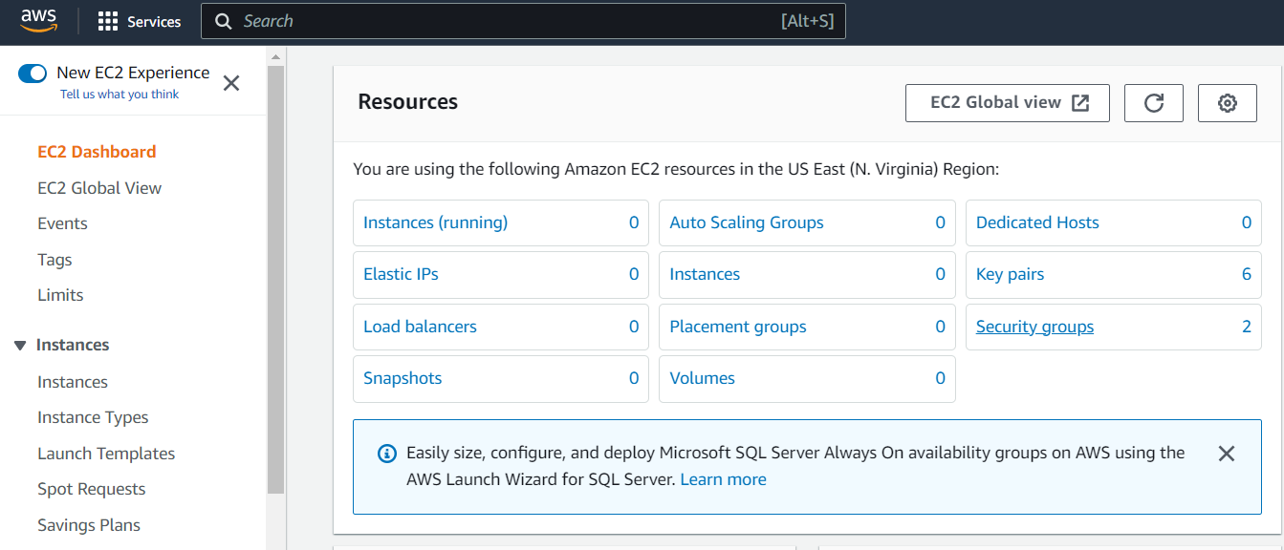

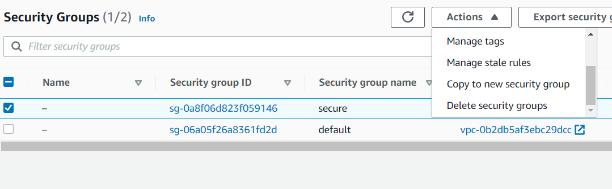

**Visit** **aws.amazon.com** **and Sign in.Go to EC2 Service and click on “Security Groups”**

**1.….**.

**2.**

**Add the Inbound rules with details as shown in the figure.After entering the details click on “Create security group”**

**Click on “Create security group”.Enter the “Security group name” and “Description”**

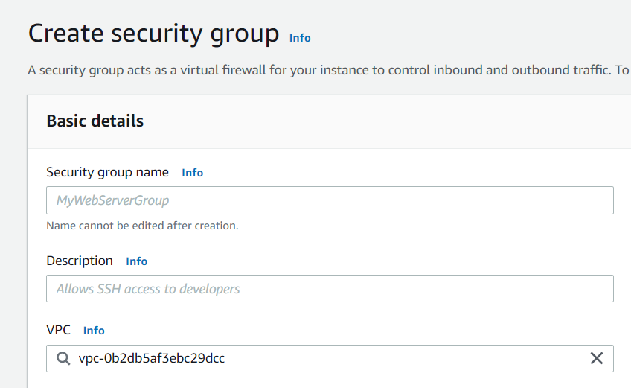

**s**

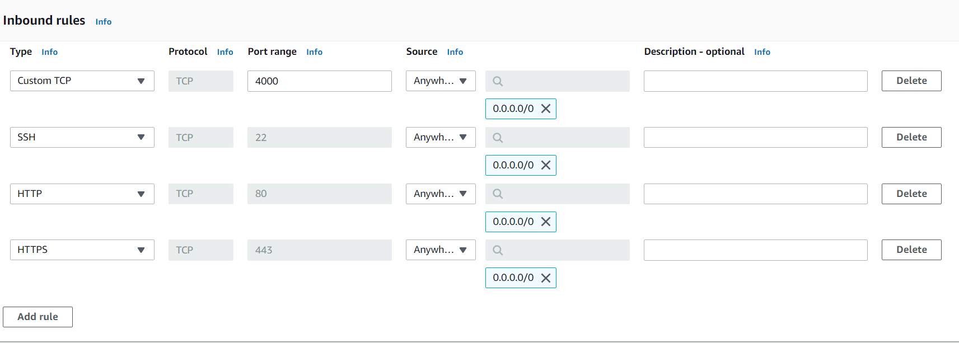

**3.**

**4.….**.



**Enter the instance name and select Ubuntu as Amazon Machine Image**

**6.**

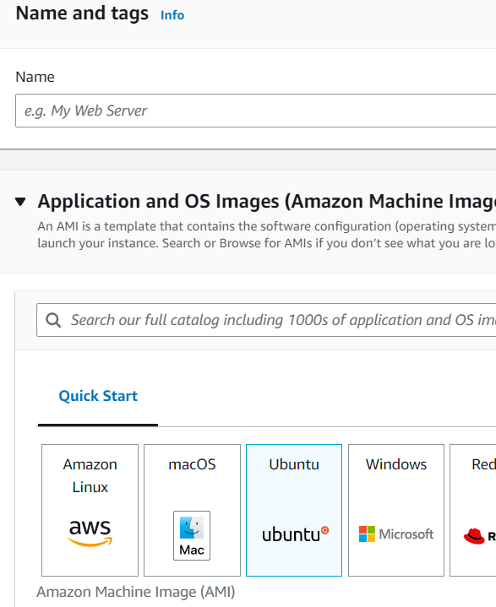

**Go to EC2 dashboard and Click on “Launch Instance”**

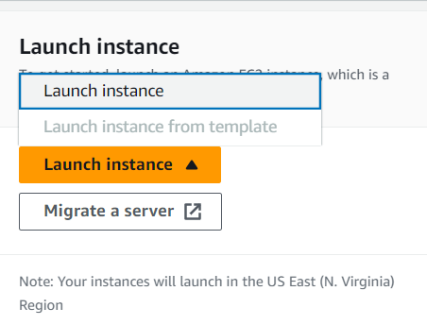

**5.**

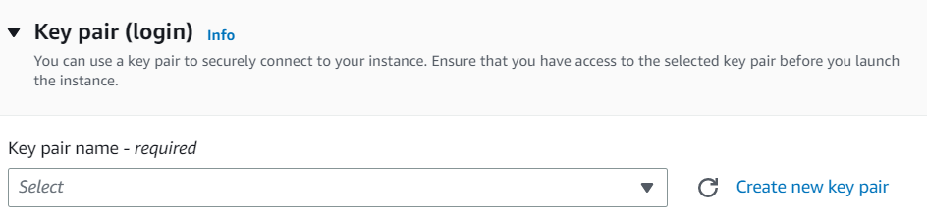

**Select key pair**

**7.**

**Under network settings ,click on “Select existing security group” and in the security group dropdown select the security group which you just created**

**8.**

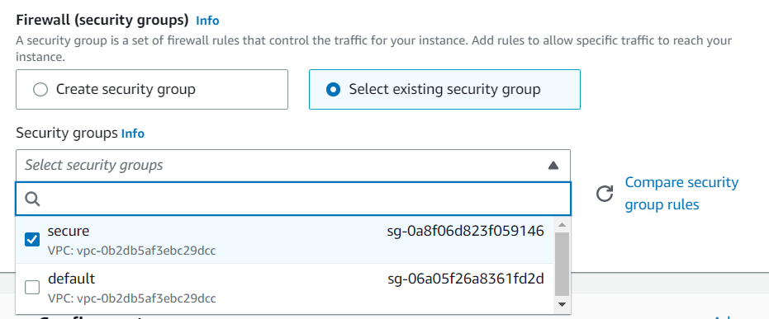

**s**

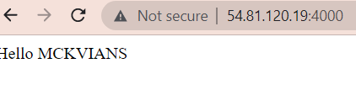

**10.**

**Type the following user data under advanced details section.Then click on create instance.**

**Now using the public ip address of the instance and the corresponding port number of the project ,we can access the project.**

**9.**

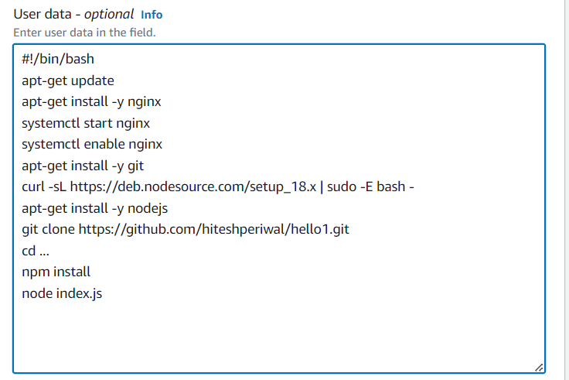

**Now type the following commands in the terminal.Keep the repository url and the github personal access token ready as they will be required in these commands**

**12.….**.

**11.**

**However for certain machines the project will not be accessible directly.To access the project,go to instance and click on connect and again click on connect**

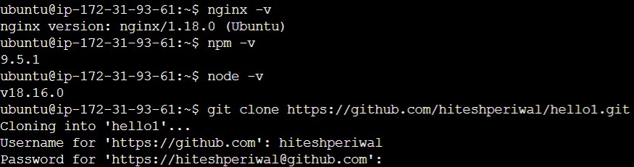

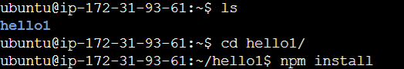



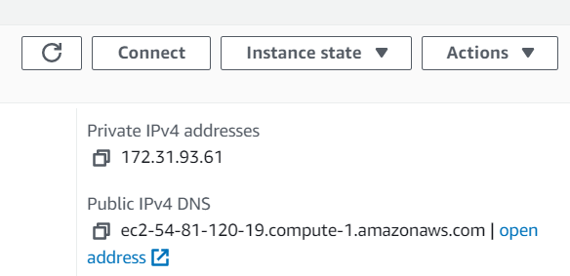

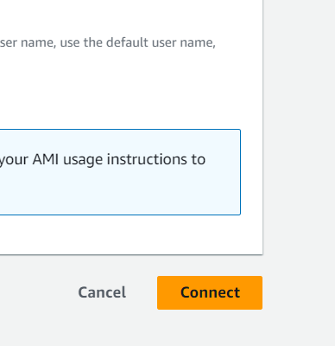



**13.**

**Now using the public ip address of the instance and the corresponding port number of the project ,we can access the project.Hence the project is successfully deployed from github to EC2 using new security group and user data**